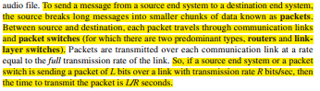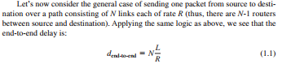
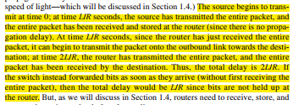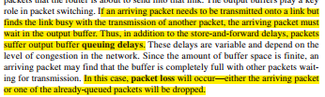

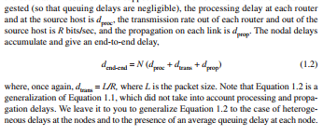
- More specifically, each router has a forwarding table that maps destination addresses (or portions of the destination addresses) to that router’s outbound links.
- In circuit-switched networks, the resources needed along a path (buffers, link transmission rate) to provide for communication between the end systems are reserved for the duration of the communication session between the end systems. In packet-switched networks, these resources are not reserved; a session’s messages use the resources on demand, and as a consequence, may have to wait (that is, queue) for access to a communication link.
- Packet switching is often considered more efficient than circuit switching for data transmission. In circuit switching, dedicated bandwidth is reserved for each user, limiting simultaneous connections. In contrast, packet switching dynamically shares the link, accommodating varying user activity levels. This results in higher overall capacity utilization and faster data transmission, especially in scenarios with intermittent user activity or when a user generates a burst of data. Packet switching offers comparable performance to circuit switching with significantly more users and is simpler and cost-effective to implement.
- In a 1 Mbps shared link, circuit switching reserves fixed bandwidth for users, limiting simultaneous connections. With packet switching, dynamic sharing allows more users, and low probability of high activity ensures performance similar to circuit switching. Additionally, in a burst scenario, packet switching efficiently utilizes the full link rate, transmitting data faster compared to circuit switching's fixed time slots.
- The most important of these delays are the nodal processing delay, queuing delay, transmission delay, and propagation delay; together, these delays accumulate to give a total nodal delay.
- The time required to examine the packet’s header and determine where to direct the packet is part of the processing delay. At the queue, the packet experiences a queuing delay as it waits to be transmitted onto the link. The transmission delay is L/R. This is the amount of time required to push (that is, transmit) all of the packet’s bits into the link. Once a bit is pushed into the link, it needs to propagate to router B. The time required to propagate from the beginning of the link to router B is the propagation delay. The bit propagates at the propagation speed of the link. The propagation speed depends on the physical medium of the link (that is, fiber optics, twisted-pair copper wire, and so on)

Why Modem?
• Signal in frequency domain
– Fourier Analysis: any periodic function can be constructed as the sum of a number of sines and consines
– Baseband DC (digital) signal has infinite harmonics
• Channel bandwidth: defined as the frequency between the highest and the lowest frequency that the channel can reliably transfer (without strong attenuation)
– limited
